820711400230

КОЖАКУЛОВА Куляш Аблаевна,
Мырзакент мектеп-гимназиясының ағылшын тілі пәні мұғалімі.
Түркістан облысы, Мақтаарал ауданы

OLYMPIC GAMES
Lesson title | Olympic Games
Learning objectives | 4.1.4.1 understand an increasing range of short supported  questions on general and some curricular topics  4.​4.​1.​1 plan, write and check sentences with support on a range of basic personal, general and some curricular topics;  4.5.12.1 use adverbs of time and frequency: sometimes, often, always, never to indicate when and how often; begin to use simple adverbs of manner e.g. well, badly; use common –ly manner adverbs to describe actions e.g. slowly, quickly
Lesson objectives | Learners will be able to:  -to talk about Olympic Games  -to learn adverbs of manner, interrogative pronouns.
Plan

Stages / Time | Teachers actions | Students actions | Assessment criteria | Resources
Start   | Organization moment :  1.Greeting.  Ask about the weather.  The teacher sets the lesson objectives, letting students know what to anticipate from the lesson.  Warm-up  Creating a positive psychological environment  Lead – In  - (An activity to revise the language of the previous lesson.)  Ask two pupils to come to the front of the classroom and act out the dialogue from the previous lesson. Repeat with as many pairs as you feel necessary.  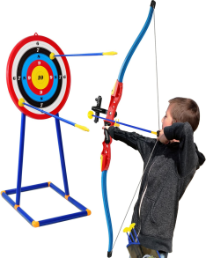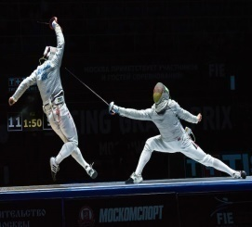 | The aim: To develop pupils speaking skills and create friendly atmosphere  Efficiency: By wishing each other they feel better and feel the support of others  Students of the class are listed.  Students' attention is drawn to the lesson.  Students analyze the given pictures in pairs.  Determines the topic and purpose of the lesson  Students say different words from the picture | At the organization moment T tries to award active pupils.  «The praise» method is used to evaluate pupils with phrases like:  “Good job!  Well done!”  Formative Assessment    Good job! | Pictures  worksheet  Student’s book
  Main part     | Ex:17 P:10  Put the Olympic games poster up on the board. Point to the Olympic games one at a time, and say the corresponding words. The pupils repeat chorally and / or individually. Point to the games in random order and ask individual pupils to name them.  Play the CD. The pupils listen, point and repeat the words. The pupils repeat chorally and / or individually. Then they complete the activity.  Ex: 18 P: 10  Explain the activity. The pupils listen and complete the activity. Ask pupils to tell you what sport each person plays well.  Study Spot  Write on the board quick-ly. Explain to the pupils that we usually from adverbs by adding –ly at the end of an adjective. Write on the board the words beautiful, bad and slow and ask the pupils to form the adverbs (beautiful – beautifully, bad – badly, slow - slowly)  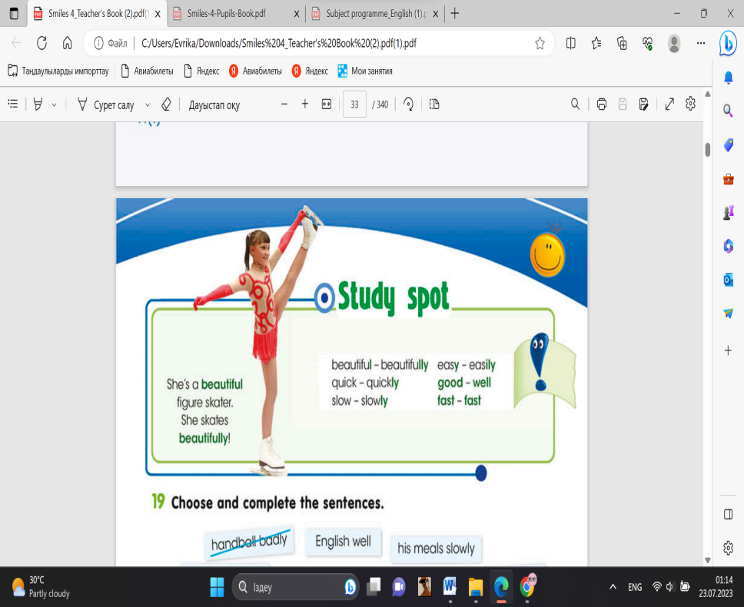  Ex:19 P:10  Read the instructions and the example the activity. Go through the phrases and the sentences and elicit any unknown words. Allow the pupils some time to complete the activity.  Conclusion during the lesson some tasks differentiated by outcomes of the students and by their abilities. | Pupils listen, point and repeat. Then match with pictures. The pupils repeat chorally and / or individually  Descriptor:  - listen, point and repeat.  - match and complete the activity  ANSWERS  2 A  3 B  4 E  5 G  6 J  7 I  8 D  9 C  10 F  Pupils listen and write.What sport do they play well?  Descriptor:  -write what sport each person plays well  ANSWERS  2 cycling  3 rugby  4 gymnastics  Pupils choose and complete the sentences.  Descriptor:  - choose and complete  ANSWERS  2 very fast  3 his meal slowly  4 English well  5 his teacher’s questions quickly  6 new sports easily  . | -can match and complete the activity  Total: 1 point  Assessment criteria  - Learners can talk about Olympic Games  -can listen and write  Total: 1 point  -can complete the sentences  Total: 1 point |   Card  Worksheet  Students book
End of the lesson | FEEDBACK  Learners provide feedback on what they have learned at the lesson.  Ex: P:  Home task: |  |  | Poster Success  

